This Virginia School Data Privacy Agreement (“DPA”) is entered into by and between the
__________________________________________ (hereinafter referred to as “Division”) and __________________________________________ (hereinafter referred to as “Provider”) on ______________ The Parties agree to the terms as stated herein.

RECITALS
WHEREAS, the Provider has agreed to provide the Division with certain digital educational services (“Services”) as described in Article I and Exhibit “A”; and
WHEREAS, in order to provide the Services described in Article 1 and Appendix A, the Provider may receive or create and the Division may provide documents or data that are covered by several federal statutes, among them, the Federal Educational Rights and Privacy Act (“FERPA”) at 20
U.S.C. 1232g and 34 CFR Part 99, Children’s Online Privacy Protection Act (“COPPA”), 15 U.S.C. 6501-6502; Protection of Pupil Rights Amendment (“PPRA”) 20 U.S.C. 1232h; the Individuals with Disabilities Education Act (“IDEA”), 20 U.S.C. §§ 1400 et. seq.; and
WHEREAS, the documents and data transferred from Virginia Divisions and created by the Provider’s Services are also subject to several Virginia student privacy laws, including Code of Virginia § 22.1-289.01. School service providers; school-affiliated entities; student personal information; and § 22.1-287.02. Students' personally identifiable information.
WHEREAS, the Parties wish to enter into this DPA to ensure that the Services provided conform to the requirements of the privacy laws referred to above and to establish implementing procedures and duties.
WHEREAS, the Provider may, by signing the “General Offer of Privacy Terms” (Exhibit “E”), agree to allow other Local Educational Agencies (LEAs) in Virginia the opportunity to accept and enjoy the benefits of this DPA for the Services described herein, without the need to negotiate terms in a separate DPA.
NOW THEREFORE, for good and valuable consideration, the parties agree as follows:

ARTICLE I: PURPOSE AND SCOPE
- Purpose of DPA. The purpose of this DPA is to describe the duties and responsibilities to protect Division Data (as defined in Exhibit “C”) transmitted to Provider from the Division pursuant to Exhibit “A”, including compliance with all applicable state privacy statutes, including the FERPA, PPRA, COPPA, IDEA, 603 C.M.R. 23.00, 603 CMR 28.00, and Code of Virginia § 22.1-289.01. School service providers; school-affiliated entities; student personal information; and § 22.1-287.02. Students' personally identifiable information. In performing these services, to the extent Personally Identifiable Information (as defined in Exhibit “C”) from Pupil Records (as defined in Exhibit “C”) are transmitted to Provider from Division, the Provider shall be considered a School Official with a legitimate educational interest, and performing services otherwise provided by the Division. Provider shall be under the direct control and supervision of the Division.
- Nature of Services Provided. The Provider has agreed to provide the following digital educational services described below and as may be further outlined in Exhibit “A” hereto:

____________________________________________________________________________________________________________________________________________________________________________________________________________________________________________________________________________________________________________________________________________________________
- Division Data to Be Provided. In order to perform the Services described in this Article and Exhibit “A”, Provider shall list the categories of data collected, managed or shared as described below or as indicated in the Schedule of Data, attached hereto as Exhibit “B”:
__________________________________________________________________________________________________________________________________________________________________________________________________________________________________________________________________________________________________________________________________________________________________________________________________________________________________________________
- DPA Definitions. The definition of terms used in this DPA is found in Exhibit “C”. In the event of a conflict, definitions used in this DPA shall prevail over terms used in all other writings, including, but not limited to, a service agreement, privacy policies or any terms of service.

ARTICLE II: DATA OWNERSHIP AND AUTHORIZED ACCESS
- Division Data Property of Division. All Division Data, user generated content or any other Pupil Records transmitted to the Provider pursuant to this Agreement is and will continue to be the property of and under the control of the Division, or to the party who provided such data (such as the student, in the case of user generated content.). The Provider further acknowledges and agrees that all copies of such Division Data or any other Pupil Records transmitted to the Provider, including any modifications or additions or any portion thereof from any source, are also subject to the provisions of this Agreement in the same manner as the original Division Data or Pupil Records. The Parties agree that as between them, all rights, including all intellectual property rights in and to Division Data or any other Pupil Records contemplated per this Agreement shall remain the exclusive property of the Division. For the purposes of FERPA and state law, the Provider shall be considered a School Official, under the control and direction of the Divisions as it pertains to the use of Division Data notwithstanding the above. The Provider will cooperate and provide Division Data within ten (10) days at the Division’s request. Provider may transfer pupil-generated content to a separate account, according to the procedures set forth below.
- Parent Access. Provider shall cooperate and respond within ten (10) days to the Division’s request for personally identifiable information in a pupil’s records held by the Provider to view or correct as necessary. In the event that a parent of a pupil or other individual contacts the Provider to review any of the Pupil Records of Division Data accessed pursuant to the Services, the Provider shall refer the parent or individual to the Division, who will follow the necessary and proper procedures regarding the requested information.
- Separate Account. Provider shall, at the request of the Division, transfer Student Generated Content to a separate student account when required by the Code of Virginia § 22.1-289.01. School service providers; school-affiliated entities.
- Third Party Request. Provider shall notify the Division in advance of a compelled disclosure to a Third Party, unless legally prohibited.
- Subprocessors. Provider shall enter into written agreements with all Subprocessors performing functions pursuant to this DPA, whereby the Subprocessors agree to protect Division Data in manner consistent with the terms of this DPA.

ARTICLE III: DUTIES OF DIVISION
- Privacy Compliance. Division shall provide data for the purposes of the DPA and any related contract in compliance with the FERPA, PPRA, IDEA, Code of Virginia § 22.1-289.01. School service providers; school-affiliated entities; student personal information; and § 22.1-287.02. Students' personally identifiable information, and all other applicable Virginia statutes.
- Parent Notification of Rights Division shall ensure that its annual notice under FERPA defines vendors, such as the Provider, as “School Officials and what constitutes a legitimate educational interest. The Division will provide parents with a notice of the websites and online services under this agreement for which it has consented to student data collection to on behalf of the parent, as permitted under COPPA
- Unauthorized Access Notification. Division shall notify Provider promptly of any known or suspected unauthorized access. Division will assist Provider in any efforts by Provider to investigate and respond to any unauthorized access.

ARTICLE IV: DUTIES OF PROVIDER
- Privacy Compliance. The Provider shall comply with all Virginia and Federal laws and regulations pertaining to data privacy and security, including FERPA, COPPA, PPRA, Code of Virginia §
22.1-289.01. and § 22.1-287.02.

- Authorized Use. Division Data shared pursuant to this DPA, including persistent unique identifiers, shall be used for no purpose other than the Services stated in this DPA and as authorized under the statutes referred to in subsection (1), above. Provider also acknowledges and agrees that it shall not make any re-disclosure of any Division Data or any portion thereof, including without limitation, any Division Data, metadata, user content or other non-public information and/or personally identifiable information contained in the Division Data, without the express written consent of the Division, unless it fits into the de-identified information exception in Article IV, Section 4, or there is a court order or lawfully issued subpoena for the information.
- Employee Obligations. Provider shall require all employees and agents who have access to Division data to comply with all applicable provisions of this DPA with respect to the data shared under the Service Agreement.
- Use of De-identified Information. De-identified information, as defined in Exhibit “C”, may be used by the Provider for the purposes of development, research, and improvement of educational sites, services, or applications, as any other member of the public or party would be able to use de- identified data pursuant to 34 CFR 99.31(b). The Provider and Division agree that the Provider cannot successfully de-identify information if there are fewer than twenty (20) students in the samples of a particular field or category of information collected, i.e., twenty students in a particular grade, twenty students of a particular race, or twenty students with a particular disability. Provider agrees not to attempt to re-identify de-identified Division Data and not to transfer de-identified Division Data to any party unless (a) that party agrees in writing not to attempt re-identification, and (b) prior written notice has been given to the Division who has provided prior written consent for such transfer.
- Disposition of Data. Upon written request and in accordance with the applicable terms in subsections below, provider shalt dispose or delete all division data obtained under this agreement when it is no longer needed for the purposes for which it was obtained. Disposition will include (1) the shredding of any hard copies of any Division data, (2) erasing, or (3) otherwise modifying the personal information in those records to make it unreadable or indecipherable by human or digital means. Nothing in the service agreement authorizes provider to maintain Division data obtained under the service agreement beyond the time reasonably needed to complete the disposition. Provider shall provide written notification when the division data has been disposed. The duty to dispose of Division data shall not extend to data that has been de-identified or placed in a separate student account, pursuant to the terms of the agreement. The division may employ a request for return or deletion of Division data form, a copy of which is attached hereto as exhibit D. Upon receipt of a request from the division, the provider will immediately provide the division with any specified portion of the division data within ten (10) calendar days of the receipt of said request.
  - Partial Disposal During the Term of Service Agreement. Throughout the term of the service agreement, Division may request partial disposal of Division data obtained under the service agreement that is no longer needed. Partial disposal of data shall be subject to Division's request to transfer data to a separate account, pursuant to Article II Section 3, above.
  - Complete Disposal upon Termination of Service Agreement. Upon termination of the service agreement provider shall dispose or securly destroy all division data obtained under the service agreement. Prior to disposal of the data, provider shall notify Division in writing of it option to transfer data to a separate account, pursuant to Article 2, Section 3, above. In new event shelters provider dispose of data pursuant to this provision unless and until provider has received affirmative written confirmation from Division that data will not be transferred to a separate account.
- Advertising Prohibition. Provider is prohibited from using or selling Division Data to (a) market or advertise to students or families/guardians; (b) inform, influence, or enable marketing or advertising efforts by a Provider; (c) develop a profile of a student, family member/guardian or group, for any commercial purpose other than providing the Service to Client; or (d) use the Division Data for the development of commercial products or services, other than as necessary to provide the Service to Client. This section does not prohibit Provider from generating legitimate personalized learning recommendations or other activities permitted under Code of Virginia § 22.1-289.01.
- Penalties. The failure to comply with the requirements of this agreement could subject Provider and any third party to all allowable penalties assessable against Provider under state and federal law. In the event the Family Policy Compliance Office of the U.S. Department of Education determines that Provider improperly disclosed personally identifiable information obtained from the Division’s education records, the Division may not allow Provider access to the Division’s education records for at least five years.

ARTICLE V: DATA PROVISIONS
- Data Security. The Provider agrees to maintain a comprehensive information security program that is reasonably designed to protect the security, privacy, confidentiality, and integrity of student personal information and makes use of appropriate administrative, technological, and physical safeguards. The general security duties of Provider are set forth below. These duties shall include, but are not limited to:
  - Passwords and Employee Access. Provider shall secure and manage usernames, passwords, and any other means of gaining access to the Services or to Division Data, at levels suggested by NIST SP800-171 (Password complexity, encryption, and re-use) , NIST SP800-53 (IA control Family), and NIST 800-63-3 (Digital Identity), and NIST SP800-63B (Authenticator and Verifier Requirements) or equivalent industry best practices.
  - Security Protocols. Both parties agree to maintain security protocols that meet industry best practices in the collection, storage or transmission of any data, including ensuring that data may only be viewed or accessed by parties legally allowed to do so. Provider shall maintain all data obtained or generated pursuant to the DPA in a secure computer environment.
  - Provider Employee Training. The Provider shall provide annual security training to those of its employees who operate or have access to the system.
  - Security Technology. When the service is accessed using a supported web browser, FIPS 140-2 validated transmission encryption protocols, or equivalent technology shall be employed to protect data from unauthorized access. The service security measures shall follow National Institute of Standards and Technology (NIST) 800-171, or equivalent industry best practices.
  - Periodic Risk Assessment. Provider further acknowledges and agrees to conduct periodic risk assessments and remediate any identified security and privacy vulnerabilities in a timely manner. Upon Division’s written request, Service Provider shall make the results of findings available to the Division. The Division shall treat such audit reports as Provider’s Confidential Information under this Agreement.
  - Backups and Audit Trails, Data Authenticity and Integrity. Provider will take reasonable measures, including all backups and audit trails, to protect Division Data against deterioration or degradation of data quality and authenticity. Provider shall be responsible for ensuring that Division Data is retrievable in a reasonable format.
  - Subprocessors Bound. Provider shall enter into written agreements whereby Subprocessors agree to secure and protect Division Data in a manner consistent with the terms of this Article V. Provider shall periodically conduct or review compliance monitoring and assessments of Subprocessors to determine their compliance with this Article.
- Unauthorized Access or Data Breach. In the event that Division Data are reasonably believed by the Provider or school division to have been disclosed (lost, accessed or obtained) in violation of the Family Educational Rights and Privacy Act (20 U.S.C. § 1232g) or other federal or state law applicable to such information accessed or obtained by an unauthorized individual, Provider shall follow the following process:
  - provide immediate notification to Division upon verification of the incident and allow the Division or its authorized representatives to fully participate in the investigation of the incident.
  - notification will be provided to the contact(s) identified in ARTICLE VII, N: Notice, and sent via email and postal mail. Such notification shall include the
    - date, estimated date, or date range of the loss or disclosure;
- Division Data that was or is reasonably believed to have been lost or disclosed;
- remedial measures taken or planned in response to the loss or disclosure.

  - immediately take action to prevent further access;
  - take all legally required, reasonable, and customary measures in working with Division to remediate the breach, which may include toll free telephone support with informed customer services staff to address questions by affected parties and/or provide monitoring services if necessary given the nature and scope of the loss or disclosure;
  - cooperate with Division efforts to communicate to affected parties.
  - provider is prohibited from directly contacting parent, legal guardian or eligible pupil unless expressly requested by Division. If Division requests Provider's assistance providing notice of unauthorized access, and such assistance is not unduly burdensome to Provider, Provider shall notify the affected parent, legal guardian or eligible pupil of the unauthorized access, which shall include the information listed in subsections (b) and (c), above. If requested by Division, Provider shall reimburse Division for costs incurred to notify parents/families of a breach not originating from Division's use of the Service.
  - the Provider shall indemnify and hold harmless the Division from and against any loss, claim, cost (including attorneys' fees) or damage of any nature arising from or in connection with the breach by the Provider or any of its officers, directors, employees, agents or representatives of the obligations of the Provider’s or its Authorized Representatives under this provision or under a Confidentiality Agreement, as the case may be.

ARTICLE VI: GENERAL OFFER OF PRIVACY TERMS
The Provider may, by signing the attached Form of General Offer of Privacy Terms (General Offer attached hereto as Exhibit “E”), be bound by the terms of this DPA to any other Division who signs the acceptance in said Exhibit. The Form is limited by the terms and conditions described therein.

ARTICLE VII: MISCELLANEOUS
- Term. The Provider shall be bound by this DPA for so long as the Provider maintains or posesses any Division Data.
- Termination. In the event that either party seeks to terminate this DPA, they may do so by mutual written consent and as long as any service agreement or terms of service, to the extent one exists, has lapsed or has been terminated. The Division may terminate this DPA and any service agreement or contract in the event of a material breach of the terms of this DPA.
- Data Transfer Upon Termination or Expiration. Provider will notify the Division of impending cessation of its business and any contingency plans. Provider shall implement its exit plan and take all necessary actions to ensure a smooth transition of service with minimal disruption to the Division. As mutually agreed upon and as applicable, Provider will work closely with its successor to ensure asuccessful transition to the new equipment, with minimal downtime and effect on the Division, all such work to be coordinated and performed in advance of the formal, transition date.
- Effect of Termination Survival. If the DPA is terminated, the Provider shall destroy all of Division’s data pursuant to Article V, section 5(b). The Provider’s obligations under this agreement shall survive termination of this Agreement until all Division Data has been returned or Securely Destroyed.
- Priority of Agreements. This DPA supersedes all end user and “click-thru” agreements. In the event there is conflict between the terms of the DPA and any other writing, such as service agreement or with any other bid/RFP, terms of service, privacy policy, license agreement, or writing, the terms of this DPA shall apply and take precedence. Except as described in this paragraph herein, all other provisions of any other agreement shall remain in effect.
- Amendments: This DPA may be amended and the observance of any provision of this DPA may be waived (either generally or in any particular instance and either retroactively or prospectively) only with the signed written consent of both parties
- Severability. Any provision of this DPA that is prohibited or unenforceable in any jurisdiction shall, as to such jurisdiction, be ineffective to the extent of such prohibition or unenforceability without invalidating the remaining provisions of this DPA, and any such prohibition or unenforceability in any jurisdiction shall not invalidate or render unenforceable such provision in any other jurisdiction. Notwithstanding the foregoing, if such provision could be more narrowly drawn so as not to be prohibited or unenforceable in such jurisdiction while, at the same time, maintaining the intent of the parties, it shall, as to such jurisdiction, be so narrowly drawn without invalidating the remaining provisions of this DPA or affecting the validity or enforceability of such provision in any other jurisdiction.
- Governing Law; Venue and Jurisdiction. This agreement will be governed by and construed in accordance with the laws of the state of Virginia, without regard to conflicts of law principles. Each party consents and submits to the sole and exclusive jurisdiction to the state and federal courts for the county of the initial subscribing division or the division specified in exhibit E as applicable, for any dispute arising out of or relating to this agreement or the transactions contemplated hereby.
- Authority. Provider represents that it is authorized to bind to the terms of this Agreement, including confidentiality and destruction of Division Data and any portion thereof contained therein, all related or associated institutions, individuals, employees or contractors who may have access to the Division Data and/or any portion thereof, or may own, lease or control equipment or facilities of any kind where the Division Data and portion thereof stored, maintained or used in any way.
- Waiver. No delay or omission of the Division to exercise any right hereunder shall be construed as a waiver of any such right and the Division reserves the right to exercise any such right from time to time, as often as may be deemed expedient.

- Successors Bound: This DPA is and shall be binding upon the respective successors in interest to provider in the event of a merger, acquisition, consolidation or other business reorganization or sale of all or substantially all of the assets of such business.
- Electronic Signature: The parties understand and agree that they have the right to execute this Agreement through paper or through electronic signature technology, which is in compliance with Virginia and Federal law governing electronic signatures. The parties agree that to the extent they sign electronically, their electronic signature is the legally binding equivalent to their handwritten signature. Whenever they execute an electronic signature, it has the same validity and meaning as their handwritten signature.
- Notice. All notices or other communication required or permitted to be given hereunder must be in writing and given by personal delivery, facsimile or e-mail transmission (if contact information is provided for the specific mode of delivery), or first class mail, postage prepaid, sent to the designated representatives before:

Designated Representatives
The designated representative for the Provider for this Agreement is:

Name: __________________________________________
Title: __________________________________________
Address: _________________________________________
eMail: _________________________________________
Phone: __________________________________________

The designated representative for the Division for this Agreement is:

Name: __________________________________________
Title: __________________________________________
Address: _________________________________________
eMail: _________________________________________
Phone: __________________________________________

  - Notification of Acceptance of General Offer of Terms. Upon execution of Exhibit E General Offer of Terms, subscribing Division shall provide notice of such acceptance in writing and given by personal delivery or email transmission (if contact information is provided for the specific mode of delivery), or first-class mail, postage prepaid, to the designated representative below the designated representative for the notice of acceptance of the general offer of privacy terms is named title contact information.

Name: __________________________________________
Title: __________________________________________
Address: _________________________________________
eMail: _________________________________________
Phone: __________________________________________

[Signature Page Follows]

IN WITNESS WHEREOF, the parties have executed this Virginia Student Data Privacy Agreement as of the last day noted below.

Provider Signature

Date: __________________________________________
Printed Name: ___________________________________
Title: _________________________________________

Division Signature

Date: __________________________________________
Printed Name: ___________________________________
Title: _________________________________________

EXHIBIT “A”
DESCRIPTION OF SERVICES

________________________________________________________________________________________________________________________________________________________________________________________________________________________________________________________________________________________________________________________________________________________________________________________________________________________________________________________________________________________________________________________

EXHIBIT “B”
SCHEDULE OF DATA

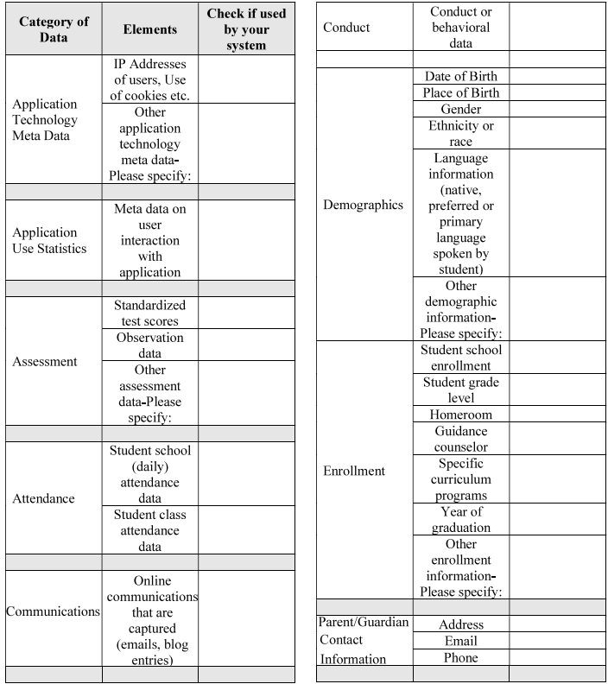

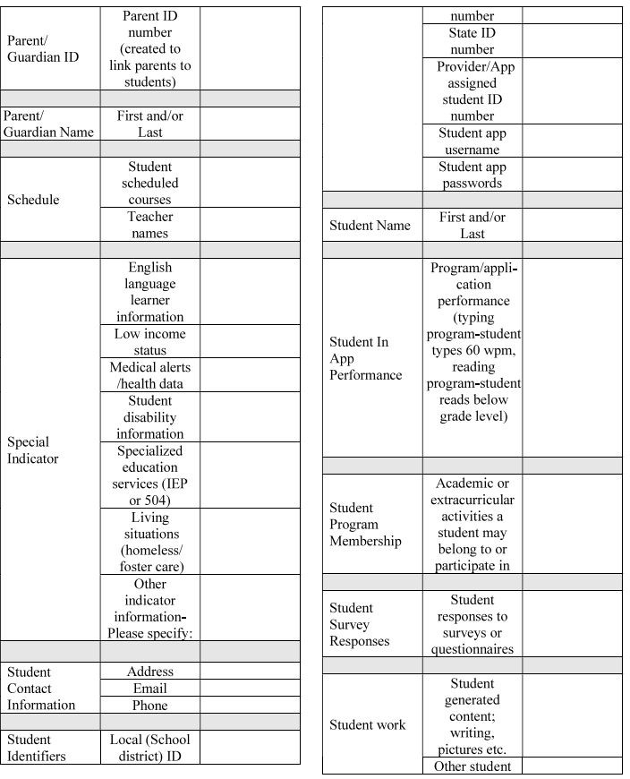

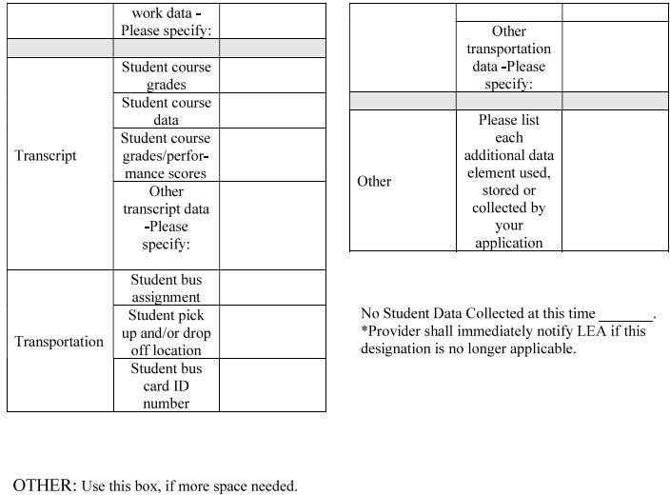

EXHIBIT “C”
DEFINITIONS

Data Breach means an event in which Division Data is exposed to unauthorized disclosure, access, alteration or use.
Division Data includes all business, employment, operational and Personally Identifiable Information that Division provides to Provider and that is not intentionally made generally available by the Division on public websites or publications, including but not limited to business, administrative and financial data, intellectual property, and student, employees, and personnel data, user generated content and metadata but specifically excludes Provider Data (as defined in the Contract).
De-Identifiable Information (DII): De-Identification refers to the process by which the Provider removes or obscures any Personally Identifiable Information (“PII”) from student records in a way that removes or minimizes the risk of disclosure of the identity of the individual and information about them. Anonymization or de-identification should follow guidance equivalent to that provided by U.S Department of Education publication “Data De-identification: An Overview of Basic Terms” or NISTIR Special Publication (SP) 8053 De-Identification of Personally Identifiable Information. The Provider’s specific steps to de-identify the data will depend on the circumstances, but should be appropriate to protect students. Some potential disclosure limitation methods are blurring, masking, and perturbation. De-identification should ensure that any information when put together cannot indirectly identify the student, not only from the viewpoint of the public, but also from the vantage of those who are familiar with the individual. Information cannot be de-identified if there are fewer than twenty (20) students in the samples of a particular field or category, i.e., twenty students in a particular grade or less than twenty students with a particular disability.
Indirect Identifiers: Any information that, either alone or in aggregate, would allow a reasonable person to be able to identify a student to a reasonable certainty
Personally Identifiable Information (PII): The terms “Personally Identifiable Information” or “PII” shall include, but are not limited to, student data, staff data, parent data, metadata, and user or pupil-generated content obtained by reason of the use of Provider’s software, website, service, or app, including mobile apps, whether gathered by Provider or provided by Division or its users, students, or students’ parents/guardians, including “directory information” as defined by §22.1-287.1 of the Code of Virginia“.
PII includes, without limitation, at least the following:
- Staff, Student or Parent First, Middle and Last Name
- Staff, Student or Parent Telephone Number(s)
- Discipline Records
- Special Education Data
- Grades
- Criminal Records
- Health Records
- Biometric Information
- Socioeconomic Information
- Political Affiliations
- Text Messages
- Student Identifiers Photos
- Videos
- Grade
- Home Address Subject
- Email Address
- Test Results
- Juvenile Dependency Records Evaluations
- Medical Records
- Social Security Number
- Disabilities
- Food Purchases
- Religious Information Documents
- Search Activity
- Voice Recordings
- Date of Birth
- Classes
- Information in the Student’s Educational Record
- Information in the Student’s Email

Provider: For purposes of the DPA, the term “Provider” means provider of digital educational software or services, including cloud-based services, for the digital storage, management, and retrieval of pupil records.
Pupil Generated Content: The term “pupil-generated content” means materials or content created by a pupil during and for the purpose of education including, but not limited to, essays, research reports, portfolios, creative writing, music or other audio files, photographs, videos, and account information that enables ongoing ownership of pupil content.
Pupil Records: Means both of the following: (1) Any information that directly relates to a pupil that is maintained by Division and (2) any information acquired directly from the pupil through the use of instructional software or applications assigned to the pupil by a teacher or other local educational Division employee.
Securely Destroy: Securely Destroy: Securely Destroy means taking actions that render data written on physical (e.g., hardcopy, microfiche, etc.) or electronic media unrecoverable by both ordinary and extraordinary means. These actions must meet or exceed those sections of the National Institute of Standards of Technology (NIST) SP 800-88 Appendix A guidelines relevant to sanitization of data categorized as high security. All attempts to overwrite magnetic data for this purpose must utilize DOD approved methodologies.
School Official: For the purposes of this Agreement and pursuant to 34 CFR 99.31 (B), a School Official is a contractor that: (1) Performs an institutional service or function for which the agency or institution would otherwise use employees; (2) Is under the direct control of the agency or institution with respect to the use and maintenance of education

VIRGINIA SCHOOL DATA PRIVACY AGREEMENT

records; and (3) Is subject to 34 CFR 99.33(a) governing the use and re-disclosure of personally identifiable information from student records.
Student Data: Student Data includes any data, whether gathered by Provider or provided by Division or its users, students, or students’ parents/guardians, that is descriptive of the student including, but not limited to, information in the student’s educational record or email, first and last name, home address, telephone number, email address, or other information allowing online contact, discipline records, videos, test results, special education data, juvenile dependency records, grades, evaluations, criminal records, medical records, health records, social security numbers, biometric information, disabilities, socioeconomic information, food purchases, political affiliations, religious information text messages, documents, student identifies, search activity, photos, voice recordings or geolocation information.
Student Data shall constitute Pupil Records for the purposes of this Agreement, and for the purposes of Virginia and Federal laws and regulations. Student Data as specified in Exhibit B is confirmed to be collected or processed by the Provider pursuant to the Services. Student Data shall not constitute that information that has been anonymized or de-identified, or anonymous usage data regarding a student’s use of Provider’s services. Anonymization or
de-identification should guidance equivalent to that provided by U.S Department of Education publication “Data De-identification: An Overview of Basic Terms” or NISTIR Special Publication (SP) 8053 De-Identification of Personally Identifiable Information.
Student Generated Content: Alternatively known as user-created content (UCC), is any form of content, such as images, videos, text and audio, that have been created and posted by student users on online platforms.
Subscribing Division: A Division that was not party to the original Services Agreement and who accepts the Provider’s General Offer of Privacy Terms.
Subprocessor: For the purposes of this Agreement, the term “Subprocessor” (sometimes referred to as the “Subcontractor”) means a party other than Division or Provider, who Provider uses for data collection, analytics, storage, or other service to operate and/or improve its software, and who has access to PII.
Third Party: The term “Third Party” means an entity that is not the Provider or Division.

EXHIBIT “D”
DIRECTIVE FOR DISPOSITION OF DATA

[Name or Division or Division] directs [Name of Company] to dispose of data obtained by Provider pursuant to the terms of the DPA between Division and Provider. The terms of the Disposition are set forth below:

- Extent of Disposition

[ ] Disposition is Complete. Disposition extends to all categories of data.
[ ] Disposition is partial. The categories of data to be disposed of are set forth below or are found in an attachment to this Directive:
[Insert categories of data]

- Nature of Disposition
[ ] Disposition shall be by destruction or secure deletion of data.
[ ] Disposition shall be by a transfer of data. The data shall be transferred to the following site as follows:

[Insert or attach special instructions.]

- Timing of Disposition

Data shall be disposed of by the following date: [ ] As soon as commercially practicable
[ ] By (Insert Date]

- Signature of Authorized Representative of Division

BY: Date:

Printed Name: Title/Position:

- Verification of Disposition of Data

BY: Date:

Printed Name: Title/Position:

OPTIONAL: EXHIBIT “E” GENERAL OFFER OF PRIVACY TERMS

  - Offer of Terms
Provider offers the same privacy protections found in this DPA between it and the Division to any other school division (“Subscribing Division”) who accepts this General Offer though its signature below. The Provider agrees that the information on the next page will be replaced throughout the Agreement with the information specific to the Subscribing Division filled on the next page for the Subscribing Division. This General Offer shall extend only to privacy protections and Provider’s signature shall not necessarily bind Provider to other terms, such as price, term, or schedule of services, or to any other provision not addressed in this DPA. The Provider and the Subscribing Division may also agree to change the data provided by Division to the Provider to suit the unique needs of the Subscribing Division. The Provider may withdraw the General Offer in the event of: (1) a material change in the applicable privacy statues; (2) a material change in the services and products subject listed in the Originating Service Agreement; or (3) after three years from the date of Provider’s signature to this form. Provider shall notify the Division in the event of any withdrawal so that this information may be transmitted to the Subscribing Divisions.

BY: Date:

Printed Name: Title/Position:

Subscribing Division
A Subscribing Division, by signing a separate Service Agreement with Provider, and by its signature below, accepts the General Offer of Privacy Terms. The Subscribing Division’s individual information is contained on the next page. The Subscribing Division and the Provider shall therefore be bound by the same terms of this DPA.

BY: Date:

Printed Name: Title/Position

TO ACCEPT THE GENERAL OFFER THE SUBSCRIBING DIVISION MUST DELIVER THIS SIGNED EXHIBIT TO THE PERSON AND EMAIL ADDRESS LISTED BELOW

BY: Date:

Printed Name: Title/Position:

Email Address

